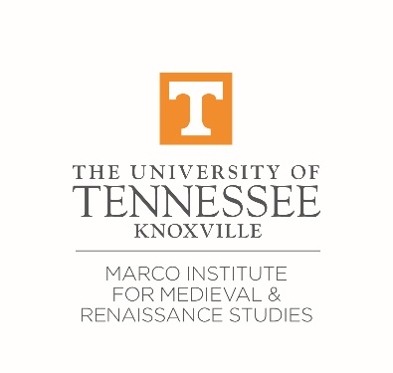

2021 MARCO SUMMER LATIN PROGRAM REGISTRATION

The Marco Summer Latin courses are free of cost for UTK students, faculty, and staff. For participants who are not at UTK, there is a flat fee of $400 ($200 for UTK alumni), payable online at the beginning of the program. Payment instructions will be emailed to you after you register.

In summer 2021, all classes will be held online using Zoom. Students with previous Latin experience may take both the beginner/review and the intermediate courses. Students may not take both readings courses. Please be advised that all courses require a substantial amount of preparation (4-5 hours) for each class session; particularly in the beginner class, students should have a minimum of other commitments. See our website for more details (marco.utk.edu/summer-latin).

REGISTRATION:

Name: Click here to enter name.

Email: Click or tap here to enter email.

Department & Institutional Affiliation: Click here to enter departmental affiliation.

Status (MA/Ph.D. student/Faculty/Other): Click here to enter status.

- What level(s) of Latin are you planning to take?

☐ Beginner/Review Section 1 – Instructor: Caitlin Branum Thrash

8-week online course, May 17–July 9, 2021
MTuThF*, 10:30 am–noon EDT
*in weeks with holidays, class will meet during the non-holiday days of the week

☐ Beginner/Review Section 2 – Instructor: Dr. Dylan Bloy

8-week online course, June 1–July 23, 2021
MTuThF*, 10:30 am–noon EDT
*in weeks with holidays, class will meet during the non-holiday days of the week

☐ Intermediate Readings (Toronto Level 1) – Instructor: Susana Kenyon

6-week online course, May 17–June 25, 2021
MTuThF, 1:00–3:00 pm EDT

☐ Advanced Readings (Toronto Level 2) – Instructor: Laura Roesch

6-week online course, June 8–July 16, 2021
TuTh, 1:00–3:00 pm EDT

- Do you have any other engagements (conference/research travel, additional job, personal travel, etc.) that will affect your attendance and/or ability to complete the course requirements?
Click here to enter text.

Please return your completed form to Marco’s program coordinator, Dr Katie Hodges-Kluck, at kthomp41@utk.edu or marco@utk.edu by April 30, 2021.

